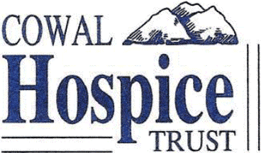
Cowal Hospice Trust

Scottish Charity No.:SC021169

Help the Cowal Hospice by Gift Aiding your Donations
If you complete the attached Gift Aid declaration the Trust can reclaim tax you have already paid to HMRC on all your donations to the Trust. The trust can claim 25p for every £1 you donate in the year, so a £100 donation becomes £125 to the Trust.

Gift Aid Declaration

I want the Cowal Hospice Trust to treat all donations I make from the date of this declaration until I notify you otherwise as Gift Aid donations.

I confirm that I have paid or will pay an annual amount of Income Tax and/or Capital Gains Tax that is at least equal to the amount of tax that all the charities which I support will reclaim on my gifts. I understand that other taxes such as VAT and Council Tax do not qualify.

Your full name: ……………………………………………………….

Your Address: ……………………………………………………….

……………………………………………………….

……………………… Post Code: ………………….

Your Signature ………………………………………………… Date of signing: ……….……………..

Notes:
- You can cancel this Declaration at any time by notifying the Treasurer.
- If you pay tax at the higher rate you can claim further tax relief in your Self Assessment tax return.
- If in the future your circumstances change and you no longer pay tax on your income and capital gains equal to the tax that the congregation and other charities you support will reclaim, you must notify the Treasurer.
- You must notify the Treasurer if you change your name or home address.

Please return this Gift Aid form to:

The Treasurer
Cowal Hospice Trust
130 Argyll Street
Dunoon
PA23 7NA

